***QUESTION BANK DATA COMMUNICATION AND NETWORKING (Unit 3 and 4)***

***Q1 what is remote control call?***

A remote procedure call is an interprocess communication technique that is used for client-server based applications. It is also known as a subroutine call or a function call.

A client has a request message that the RPC translates and sends to the server. This request may be a procedure or a function call to a remote server. When the server receives the request, it sends the required response back to the client. The client is blocked while the server is processing the call and only resumed execution after the server is finished.

***Q2 what is IP address? Explain it briefly.***

An IP address is a unique address that identifies a device on the internet or a local network. IP stands for "Internet Protocol," which is the set of rules governing the format of data sent via the internet or local network.

***Q3 Explain sliding window protocol?***

The sliding window is a technique for sending multiple frames at a time. It controls the data packets between the two devices where reliable and gradual delivery of data frames is needed. It is also used in [TCP (Transmission Control Protocol)](https://www.javatpoint.com/tcp).

In this technique, each frame has sent from the sequence number. The sequence numbers are used to find the missing data in the receiver end. The purpose of the sliding window technique is to avoid duplicate data, so it uses the sequence number.

## Types of Sliding Window Protocol

Sliding window protocol has two types:

1. Go-Back-N ARQ
2. Selective Repeat ARQ

### Go-Back-N ARQ

Go-Back-N ARQ protocol is also known as Go-Back-N Automatic Repeat Request. It is a data link layer protocol that uses a sliding window method. In this, if any frame is corrupted or lost, all subsequent frames have to be sent again.

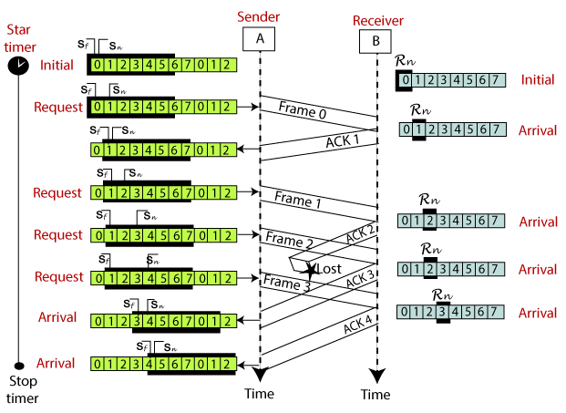

### Selective Repeat ARQ

Selective Repeat ARQ is also known as the Selective Repeat Automatic Repeat Request. It is a data link layer protocol that uses a sliding window method. The Go-back-N ARQ protocol works well if it has fewer errors. But if there is a lot of error in the frame, lots of bandwidth loss in sending the frames again. So, we use the Selective Repeat ARQ protocol. In this protocol, the size of the sender window is always equal to the size of the receiver window. The size of the sliding window is always greater than 1.

### Difference between the Go-Back-N ARQ and Selective Repeat ARQ?

|  |  |
| --- | --- |
| **Go-Back-N ARQ** | **Selective Repeat ARQ** |
| If a frame is corrupted or lost in it,all subsequent frames have to be sent again. | In this, only the frame is sent again, which is corrupted or lost. |
| If it has a high error rate,it wastes a lot of bandwidth. | There is a loss of low bandwidth. |
| It is less complex. | It is more complex because it has to do sorting and searching as well. And it also requires more storage. |
| It does not require sorting. | In this, sorting is done to get the frames in the correct order. |
| It does not require searching. | The search operation is performed in it. |
| It is used more. | It is used less because it is more complex. |

***Q4 What is linear block code?***

| S. No | **Linear Block Codes** | **Convolutional Codes** |
| --- | --- | --- |
| 1. | Block codes take k input bits and produce n output bits where k and n are very large. (when k>1), k is the number of message bits | Convolutional codes take a small number of input bits and produce a small number of output bits for each period. (when K=1). |
| 2. | In Linear Block codes, information bits are immediately followed by the parity bits. | In Convolutional codes, information bits are not followed by parity bits instead spread along the sequence. |
| 3. | Encoding of the current state is independent of the previous state and thus it does not have any memory element. It depends only upon the present message bit. | Encoding of the current state depends on the previous state and past elements, thus it has a memory element for storing previous state information. |
| 4. | Block codes are preferred in systematic form and have an efficient structure i.e position of parity or check bits is well defined | Convolutional codes are preferred in the non-systematic form and no such efficient structure i.e position of parity or check bits is not defined |
| 5. | Block codes are suitable for detecting and preventing random errors | Convolutional codes are suitable for detecting and preventing burst errors |
| 6. | The hardware component of Block codes is complex and the encoding process is a bit difficult. | The hardware component of Convolutional Codes is simpler and the encoding process is easy. |
| 7. | Types of Linear Block codes are Hamming codes, BCH codes, cyclic codes, Reed-Solomon codes | Types of Convolutional codes are Turbo codes and Trellis code |

***Q5 Explain aloha?***

ALOHA is a multiple access protocol for transmission of data via a shared network channel. It operates in the medium access control sublayer (MAC sublayer) of the open systems interconnection (OSI) model. Using this protocol, several data streams originating from multiple nodes are transferred through a multi-point transmission channel.

In ALOHA, each node or station transmits a frame without trying to detect whether the transmission channel is idle or busy. If the channel is idle, then the frames will be successfully transmitted. If two frames attempt to occupy the channel simultaneously, collision of frames will occur and the frames will be discarded. These stations may choose to retransmit the corrupted frames repeatedly until successful transmission occurs.

## Versions of ALOHA Protocols

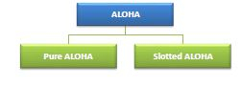

## Pure ALOHA

In pure ALOHA, the time of transmission is continuous.Whenever a station hasan available frame, it sends the frame. If there is collision and the frame is destroyed, the sender waits for a random amount of time before retransmitting it.

## Slotted ALOHA

Slotted ALOHA reduces the number of collisions and doubles the capacity of pure ALOHA. The shared channel is divided into a number of discrete time intervals called slots. A station can transmit only at the beginning of each slot. However,there can still be collisions if more than one station tries to transmit at the beginning of the same time slot.

***Q6 Explain error detection and correction?***

***Q7 Differentiate b/w transport and session layer?***

***Q8 Write the features of***

1. ***Point to point***
2. ***Routing***
3. ***Congestion control***
4. ***Tcp***

***Q9 What are the issues in presentation layer?***

***Q10 Write a short note on:***

1. ***Data compression techniques***
2. ***Channel allocation***

***Q11 Give a brief description of FDDI .***

***Q12 What are cyclic codes?***

***Q13 Define cryptography.***

***Q14 What is packet switching?***

***Q15 What is connection management?***

***Q16 Explain block coding?***

***Q17 Give a brief note on Network layer.***

***Q18 How many layers are there under TCP/IP?***

***Q19 What is data link layer?***

***Q20 What is an IP packet?***

***Q21 Explain data compression and its types?***